**LAB-2 REPORT**

**1**) Choose any devices (Android smartphone, Sensor Tag, Chronos Watch). Implement an application to generate a file for your activities

Here, I took android Smartphone to implement an app to generate a file or collect a data to insert into Hbase .

first install the astrofilemanager in the android phone and we collect data by using sensortag app

and then modified code in the app1- app3 sensortag gps sample code to include temperature and humidity parameters and then txt file is generated as follows

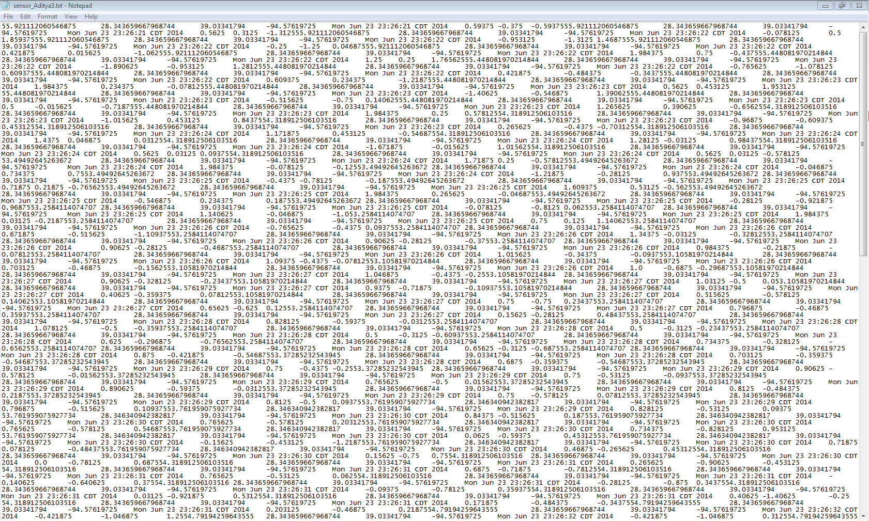

The below screen shot shows all the services UUID tags:

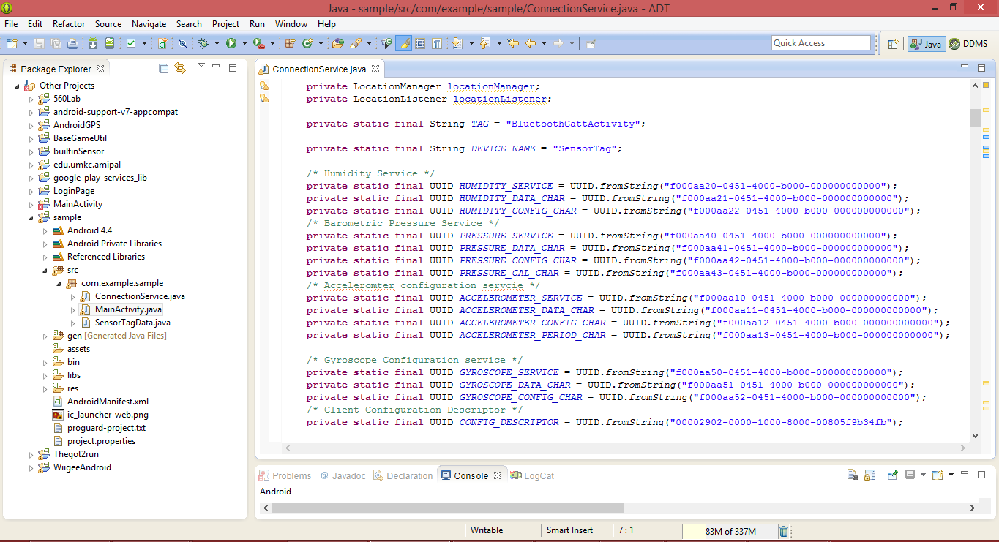

the different cases where the program enters each loop and collect the required data of the particular service.

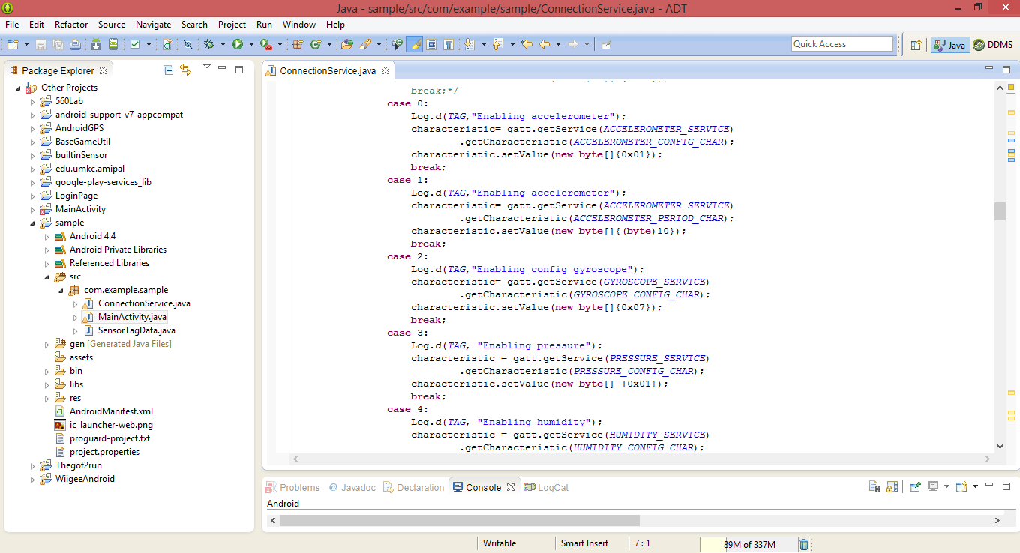

the Log File of data collecting the accelerometer values indicating as X,Y and Z.

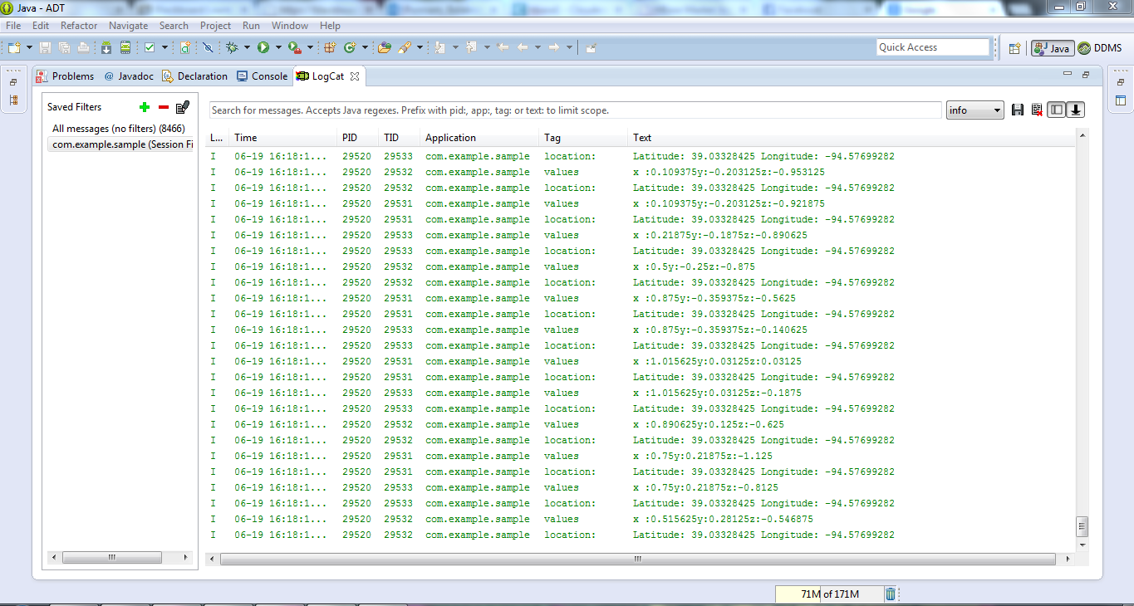

collected data from the sensor given with the tab spaces for each value

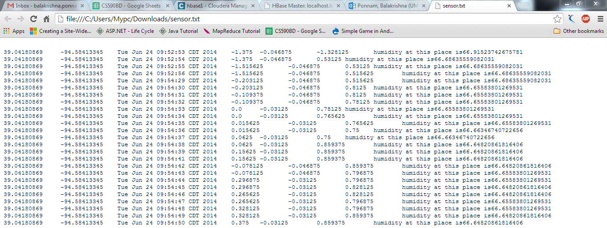

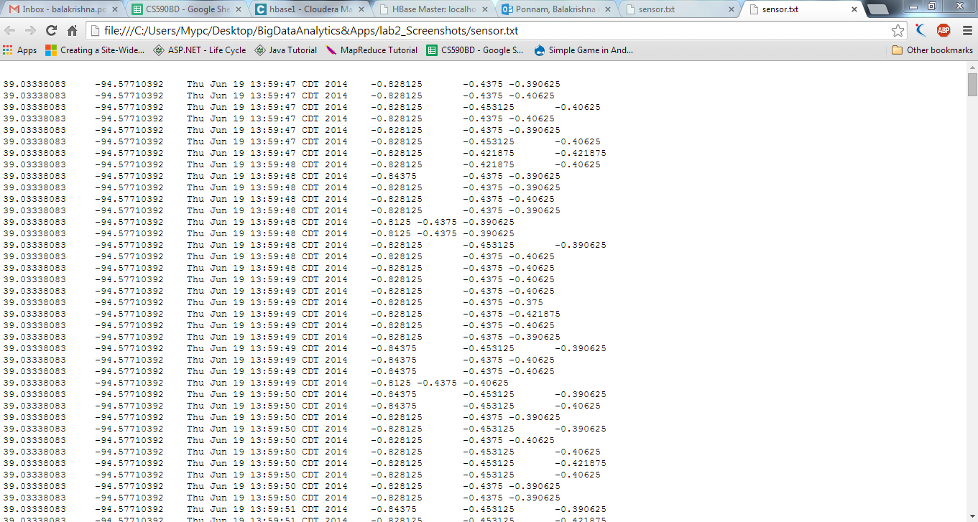

creation of new table at run time:

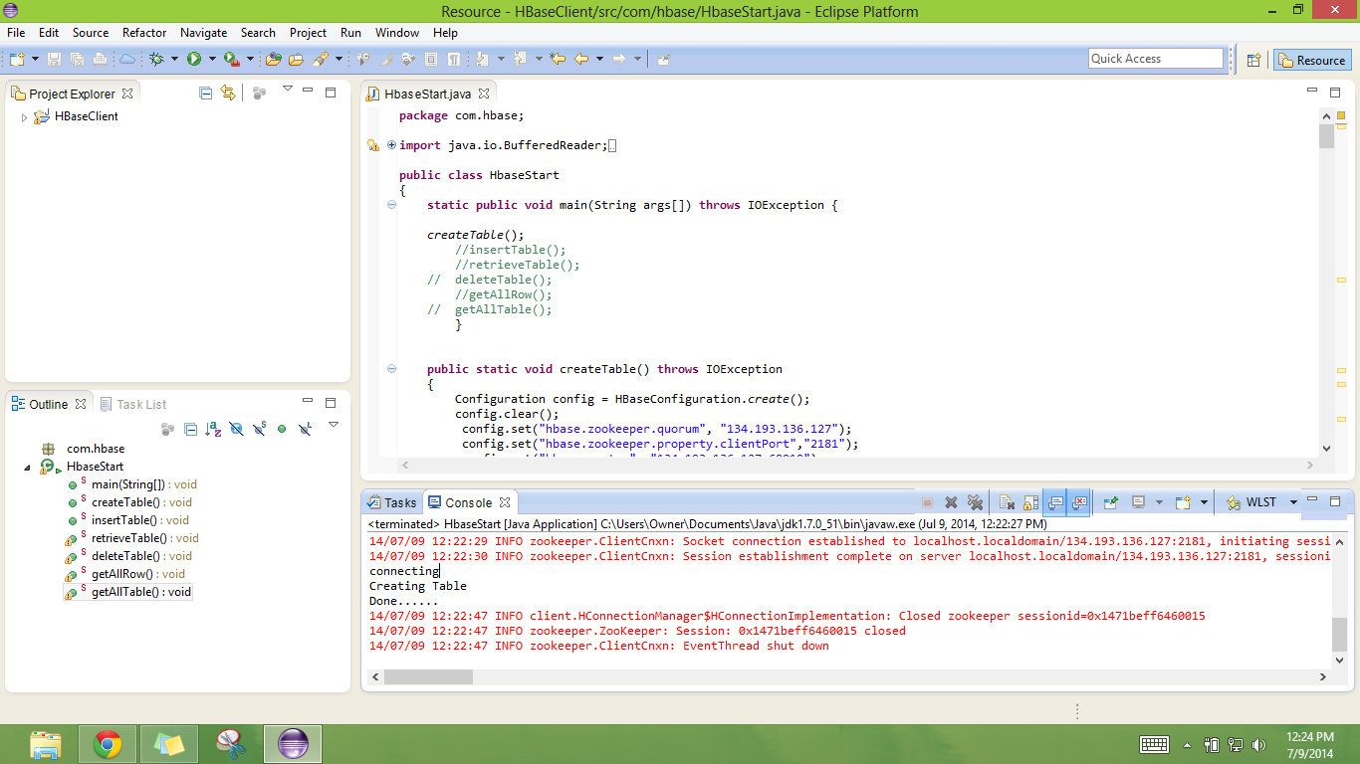

Below is the screen shot of the created table showing in the UI of HBase

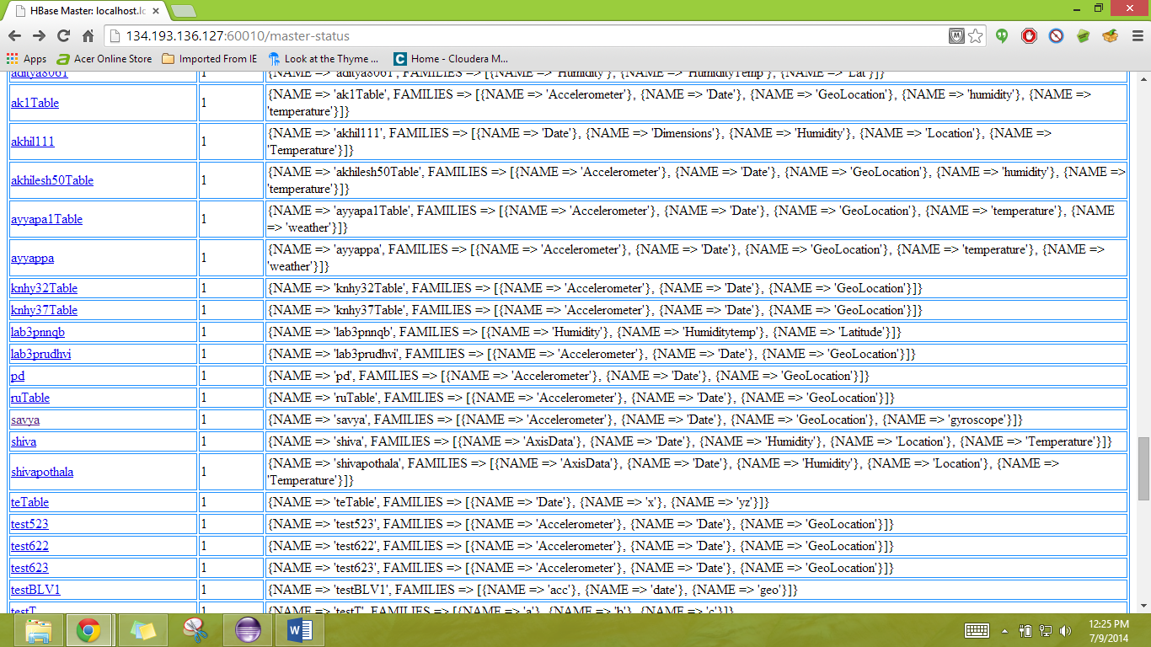

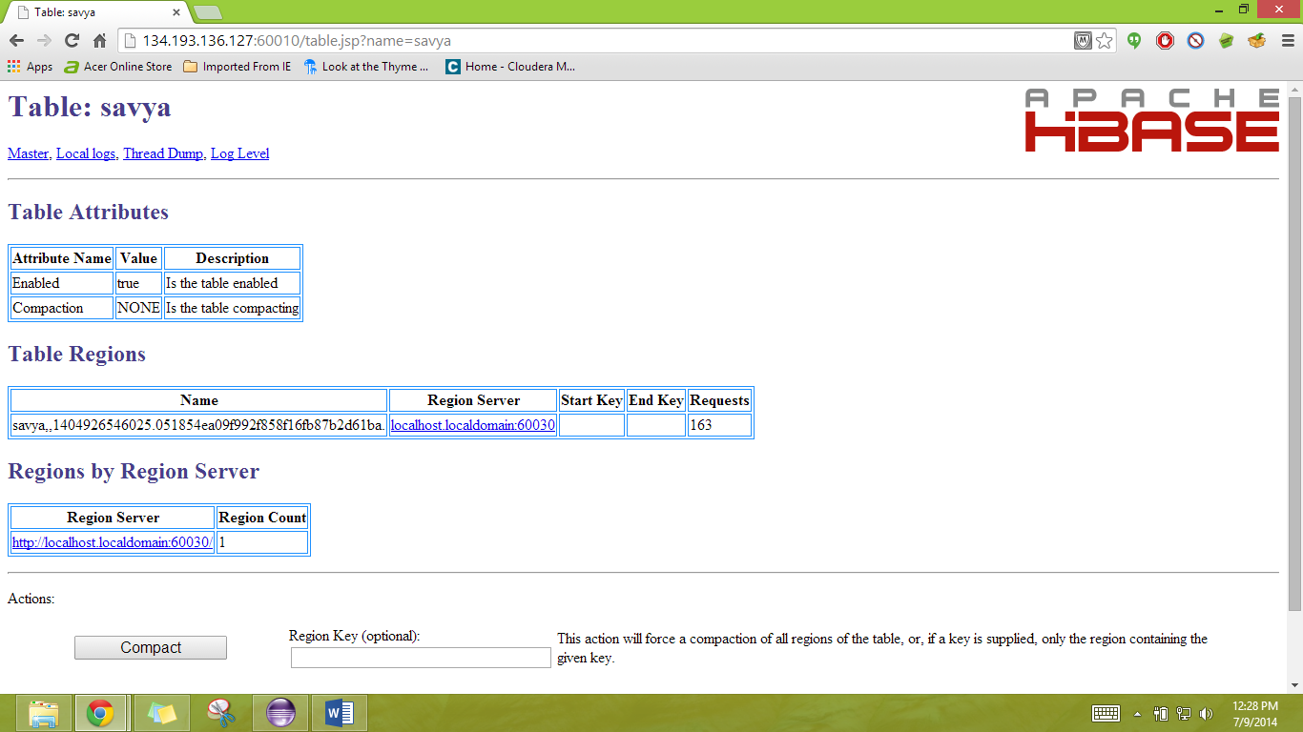

retrieving of data screen shot

